Yummy

National College of Ireland

HDCSDEV_INT Higher Diploma in Science in Computing

Kefeng Hao & Qiang Nie

Screenshot web homepage:

Contents

1. Executive summary 3

2. Design Process 3

2.1. Research & Investigation 3

**2.2. Requirements & Technical Approach** 4

**2.3. Design & Wireframe** 5

2.3.1. UI Kit Design 5

**2.3.2. Wireframe** 5

3. **Project Work** 8

3.1. Break Down of Tasks 8

**4. Development** 8

4.1. Bootstrap Implementation 8

4.2. Validation 8

4.3. Optimization & SEO 11

4.4. Testing & Responsiveness 11

4.4.1. Responsiveness 11

4.4.2. JavaScript: validation & if statements 11

4.6. Website Deployment 12

**5. Conclusion** 12

5.1. Result, Achievements, Teamwork, and Possible Improvemen 12

6. Reference 14

# Executive Summary

This project aims to build some webpages for a fast-food restaurant. Our team has decided to name it Yummy. The United States dominates the fast-food industry market, so we aim to create one that can compete effectively. Our team has two members: Kefeng Hao and Qiang Nie.

We decided to build six pages and they are Home, explore All menus, Location, Contact us and Our App.

page layout, navigation, colour scheme,

# 2. Design Process

## **2.1. Research & Investigation**

Our team has taken webpages from McDonald’s, KFC and Domino as references. They are leading brands and the most popular fast-food restaurants. We particularly focused on McDonald’s as a primary example due to its clear and user-friendly web pages.

Fig.1 Odeon Cinemas. (n.d.). Home. Retrieved December 2, 2024, from

<https://www.mcdonalds.com/ie/en-ie.html>

Fig.2 Odeon Cinemas. (n.d.). Home. Retrieved December 2, 2024, from

<https://www.kfc.ie/>

Fig.3 Odeon Cinemas. (n.d.). Home. Retrieved December 2, 2024, from

<https://www.dominos.ie/store/27379/dublin-north-docks/menu>

## **2.2. Requirements & Technical Approach**

There are several requirements for this project.

1. The website needs to showcase and promote the dining brand.

2. Menu content guidance and full menu display.

3. Information form filling and validation.

4. Map search functionality.

5. Download link for the dining app.

To meet these requirements, we have decided to create six pages: Home, Explore, All Menu, Locations, Contact Us, and Our App. Our plan is to build the website structure and write the content using HTML and CSS, then use JavaScript to add functionality and interactivity, and enhance the styling with Bootstrap.

## **2.3. Design & Wireframe**

### 2.3.1. UI Kit Design

Since the restaurant we designed features a warm color theme, we chose warm orange and white as the primary theme colors. To enhance users’ curiosity and encourage exploration, we designed an Explore page to guide customers quickly to the menu and incorporated a Google Maps module to help customers locate the restaurant.

Qiang Nie used Figma to create a UI Kit for this project, which includes the color scheme, fonts, button designs, logo, and navigation bar. All team members will consistently apply these designs across all pages to ensure a cohesive look and feel for the website.

### **2.3.2. Wireframe**

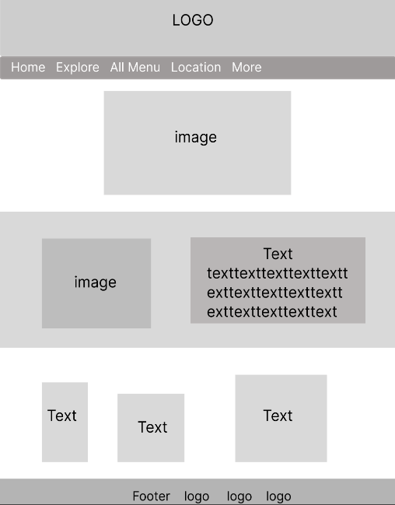

Fig.4 Home page (created by Qiang Nie)

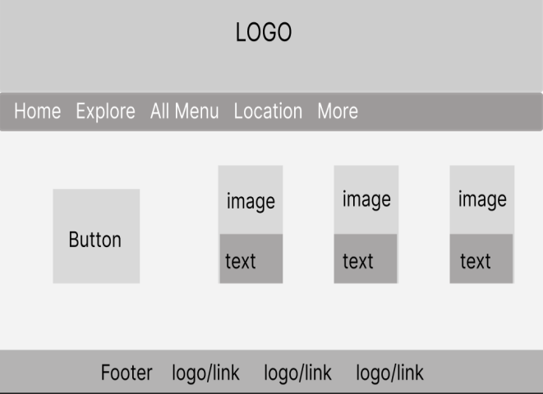

Fig.5 Explore Page (created by Qiang Nie)

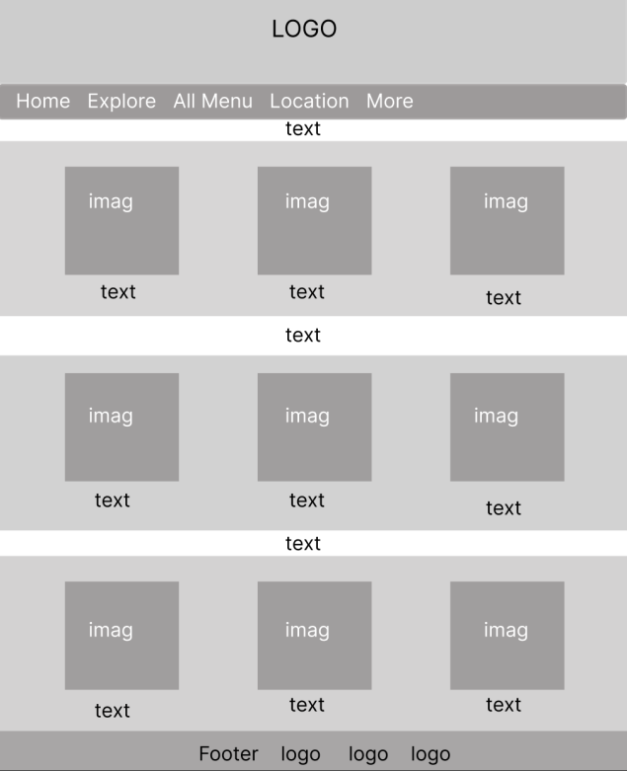

Fig.6 All Menu Page (created by Qiang Nie)

Fig.7 Location Page (created by Kefeng Hao)

Fig.8 Contact Us Page (created by Kefeng Hao)

Fig.9 Our App Page (created by Kefeng Hao)

## 3. **Project Work**

### 3.1. Break Down of Tasks

At the beginning of this project, our team set a clear goal and assigned tasks to each team member. In addition to using common CSS style, we also created our own CSS styles.

Student Kefeng Hao needs to design and build three webpages: Location, Contact Us and Our App. He also built JavaScript file, worked on validation and optimization.

Student Qiang Nie is responsible for creating the Home page, the Explore page, and the All Menu page, which includes navigation buttons and an image gallery. He also made the overall UI design for all pages.

## **4. Development**

### **4.1. Bootstrap Implementation**

Our webpage uses Bootstrap to implement the Navigation Bar,Buttons, forms and Dropdown Menus.

Bootstrap Navigation Bar**:** we created navigation bars in every page, which located below the footer.

Dropdown Menus: we used Bootstrap to create a dropdown menu in the navigation bar.

Buttons: We created buttons with different colours and shapes in three pages.

Boostrap Forms: we created forms in contact us page.

Fig.10 Bootstrap implementation.

### **4.2. Validation**

We used the W3C online validator to check for errors. There are some errors and warnings after validating our Html. In addition, there was only one error in our CSS file. Error message informed duplicate ID because there is duplicate code. We also wrongly added “px” in width and height sections. We realized that only numeric values can be placed inside double quotes, or we could use the attribute “style” to specify the size of the element. This error was caused by a mistake we made during our work, so we decided to delete the code to resolve the error.

Fig.11 Errors returned by validator.

Fig. 12 No error returned after modification.

Fig.13 Group CSS validation: Errors returned by validator.

Fig.14 Group CSS validation: no error returned.

Fig.15 Individual CSS validation: no error returned.

### **4.3. Optimization & SEO**

We optimized our webpages by using Image optimization. We used an online image optimizer to optimize our images.

Fig.16 Image optimization by using online optimizer

### **4.4. Testing & Responsiveness**

### **4.4.1. Responsiveness**

Nav bar was implemented in our webpage

We added a meta viewport tag in the head section, with its content “width=device-width, initial-scale=1.0” setting in every pages.

### **4.4.2. JavaScript: validation & if statements**

In our website, there are two pages (Contact us and Locations) for user to input their information. We created two JavaScript files to validate input information. The basic logic is to validate if the input information is empty, and if the input is empty or invalid, an error message appears, and the input field is also highlighted. If the input is not empty, the JavaScript file would validate whether it follows the common pattern. For example, if a user input “22222222” eight digits in Eircode section, he will be informed he needs to input a valid Eircode because a typical Eircode consists of 7 digits and characters. Below is screenshots of our JavaScript and test results:

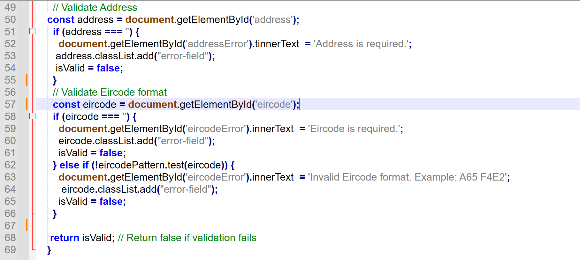

Fig.17 JavaScript for validation

Fig.18 The feedback form test

Fig.19 The Search Bar test

### **4.6. Website Deployment**

Our website was deployed on Github:

<https://kfgituser.github.io/Web-CA2/>index.html

Fig. Link to the deployed website.

## **5. Conclusion**

5.1. Result, Achievements, Teamwork, and Possible Improvements.

# 6. Reference

GreatStack. (n.d.). YouTube. [Online] Available at: [https://www.youtube.com/watch?v=4U_AAGHzTok&list=PLBEwZ0AjYXJ12b_GbIEE8wrClMqmxqRkp&index=9.](https://www.youtube.com/watch?v=4U_AAGHzTok&list=PLBEwZ0AjYXJ12b_GbIEE8wrClMqmxqRkp&index=9)

[Accessed December 03, 2024].